Hong Kong Exchanges and Clearing Limited and The Stock Exchange of Hong Kong Limited take no responsibility for the contents of this announcement, make no representation as to its accuracy or completeness and expressly disclaim any liability whatsoever for any loss however arising from or in reliance upon the whole or any part of the contents of this announcement.

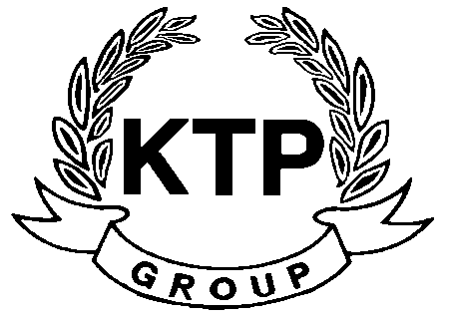
KTP HOLDINGS LIMITED
(Incorporated in Bermuda with limited liability)
(Stock Code: 645)
SUPPLEMENTARY ANNOUNCENMENT RELATING TO
THE ANNUAL RESULTS FOR THE YEAR ENDED 31ST MARCH 2010

The Board wishes to provide supplementary information with respect to the Announcement regarding the annual results of the Group for the year ended 31st March 2010.

Reference is made to the announcement of KTP Holdings Limited (the “Company”) dated 16th July 2010 (the “Announcement”) regarding the annual results of the Group for the year ended 31st March 2010. Unless otherwise defined, terms used in this announcement shall have the same meanings as those used in the Announcement.

The Board wishes to provide supplementary information to the business review as required by Appendix 16 paragraph 45(3) (b) and (c) in relation to an event after the end of the reporting date and the business prospects of the Group as follows:

EVENT AFTER THE END OF THE REPORTING DATE

On 9th July 2010, the Company entered into a memorandum of sale and purchase with Joyart Corporation Limited, an independent third party, to dispose of its leasehold building in Hong Kong for a consideration of HK$8,500,000 (equivalent to approximately US$1,090,000).

PROSPECTS

The Group will continue the principal activity of footwear products manufacturing and will strive for exploring new business opportunities, thus enhancing shareholders value in the coming year.

By Order of the Board
KTP Holdings Limited
Yu Mee See, Maria
Director
Hong Kong, 21st July 2010

As at the date of this announcement, the executive directors are Mr. Lee Chi Keung, Russell (Chairman), Ms. Yu Mee See, Maria and the independent non-executive directors are Mr. Ng Wai Hung, Mr. Lee Siu Leung and Mr. Yuen Sik Ming.

